Azure Virtual Machines (VMs) provide full hardware virtualization with dedicated OS instances, ideal for legacy apps and heavy, isolated workloads. Conversely, containers (e.g., Azure Container Instances, AKS) share the host OS kernel, offering lightweight, portable, and fast-starting environments perfect for microservices and cloud-native applications. [1, 2]

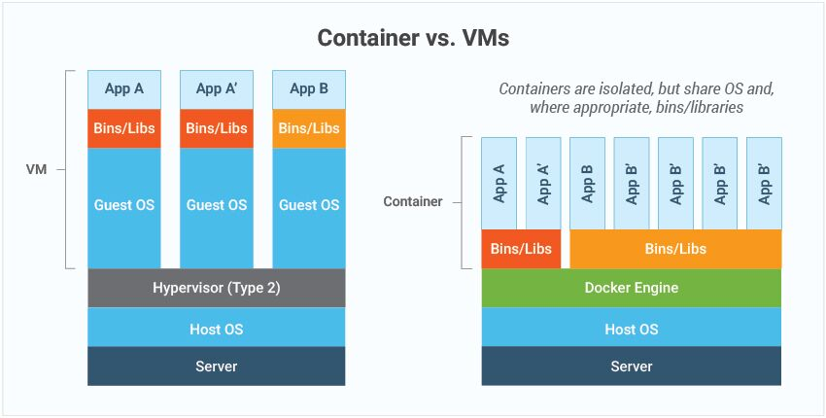
https://www.eginnovations.com/blog/containers-vs-vms/
http://k21academy.com/kubernetes/docker-vs-virtual-machine/

Key Differences at a Glance [1, 2]
Feature [1, 2, 3, 4, 5] | Virtual Machines | Containers
Virtualization | Hardware-level (via Hypervisor) | OS-level (via Container Engine)
Operating System | Full Guest OS (slow boot) | Shared Host OS (fast boot)
Size | Large (Gigabytes) | Lightweight (Megabytes)
Isolation | High (Complete isolation) | Process-level (Lower than VM)
Portability | Lower (VM images) | High (Portable across clouds)
Use Cases | Legacy apps, desktop-as-a-service | Microservices, DevOps, CI/CD
Azure Virtual Machines
- Best For: Applications requiring deep OS-level control, specific OS dependencies, or migrating legacy "lift-and-shift" workloads to the cloud.
- Management: Higher overhead; users must patch and maintain the OS.
- Isolation: Maximum security boundary, good for running untrusted code or competing workloads. [1, 2, 3, 4, 5]
Azure Containers (ACI, AKS, App Service) [1]
- Best For: Modern, microservices-based applications, temporary tasks (batch jobs), and rapid scaling.
- Management: Lower overhead (PaaS); abstracts the OS maintenance, allowing focus on code.
- Efficiency: High density allows running many more containers per host than VMs. [1, 2, 3, 4, 5]
When to Choose Which
- Use VMs if: You need a completely different OS, need to run legacy software, or require strict hardware-level isolation.
- Use Containers if: You are building cloud-native apps, need fast deployment, or want to maximize resource utilization, often managed by Azure Kubernetes Service (AKS). [1, 2, 3, 4, 5]

Microservices are small, independent, and loosely coupled components that a single small team of developers can write and maintain. Each service is managed as a separate codebase, which allows a small team to handle it efficiently. Because services can be deployed independently, teams can update existing services without rebuilding or redeploying the entire application. https://learn.microsoft.com/en-us/azure/architecture/guide/architecture-styles/microservices

Azure Container Instances (ACI) is a serverless service that allows you to run Docker containers in Azure without managing underlying Virtual Machines (VMs) or orchestrators. It offers instant deployment, per-second billing, and high isolation, making it ideal for fast startup times, bursting, batch jobs, and simple applications. [1, 2, 3, 4]
Key Benefits of Azure Container Instances
- No Server Management: ACI removes the need to provision, patch, or manage VMs. You deploy your container image, and Azure handles the infrastructure.
- Fast Startup Times: Containers start in seconds, which is significantly faster than launching traditional VMs.
- Cost-Efficient (Per-Second Billing): You only pay for the exact duration your container runs, calculated per second based on vCPU and memory allocation.
- High Security & Isolation: ACI provides hypervisor-level isolation, ensuring your application is as secure as it would be in a dedicated VM.
- Flexible Sizing: You can precisely define the CPU and memory resources required for your application, allowing for optimized performance and cost.
- Scalability & Bursting: ACI is ideal for handling traffic spikes. It integrates with Azure Kubernetes Service (AKS) using virtual nodes to provide elastic scaling without adding more server nodes.
- Persistent Storage: You can directly mount Azure Files shares to container instances for stateful applications. [1, 2, 3, 4, 5, 6, 7]
Common Use Cases
- Data Processing Jobs: Ideal for short-lived, batch processing tasks.
- CI/CD Agents: Running build and testing agents for DevOps pipelines.
- Event-Driven Applications: Responding to events or triggers, such as processing messages from an Azure Queue.
- Application Bursting: Using ACI to handle unpredictable, high-demand traffic spikes. [1, 2, 3, 4, 5]
Key Features
- Support for Linux and Windows: ACI can run both types of container images.
- Networking: Public IP addresses or private virtual network (VNet) support allows secure communication.
- Custom Images: Deploy images from Docker Hub or Azure Container Registry (ACR).
- Multi-container Groups: Supports deploying groups of containers that share a lifecycle, resources, and local network, similar to a Kubernetes pod. [1, 2, 3, 4, 5]
ACI is the simplest way to run containers in Azure when you don't need full container orchestration (like Kubernetes). [1, 2]

Container groups in Azure Container Instances: https://learn.microsoft.com/en-us/azure/container-instances/container-instances-container-groups
Summarize this article for me
The top-level resource in Azure Container Instances is the container group. This article describes what container groups are and the types of scenarios they enable.
What is a container group?
A container group is a collection of containers that get scheduled on the same host machine. The containers in a container group share a lifecycle, resources, local network, and storage volumes. It's similar in concept to a pod in Kubernetes.
The following diagram shows an example of a container group that includes multiple containers:
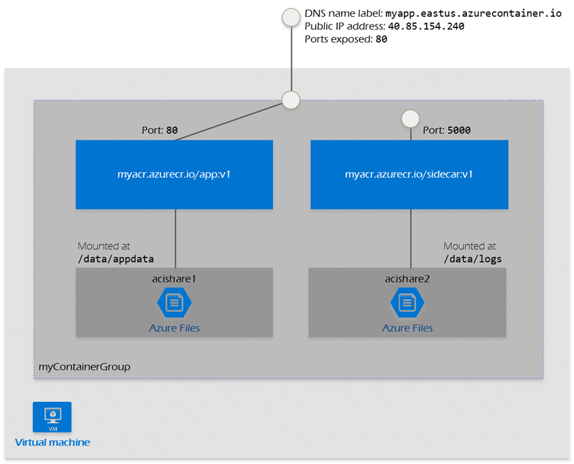
This example container group:
- Is scheduled on a single host machine.
- Is assigned a DNS name label.
- Exposes a single public IP address, with one exposed port.
- Consists of two containers. One container listens on port 80, while the other listens on port 5000.
- Includes two Azure file shares as volume mounts, and each container mounts one of the shares locally.

